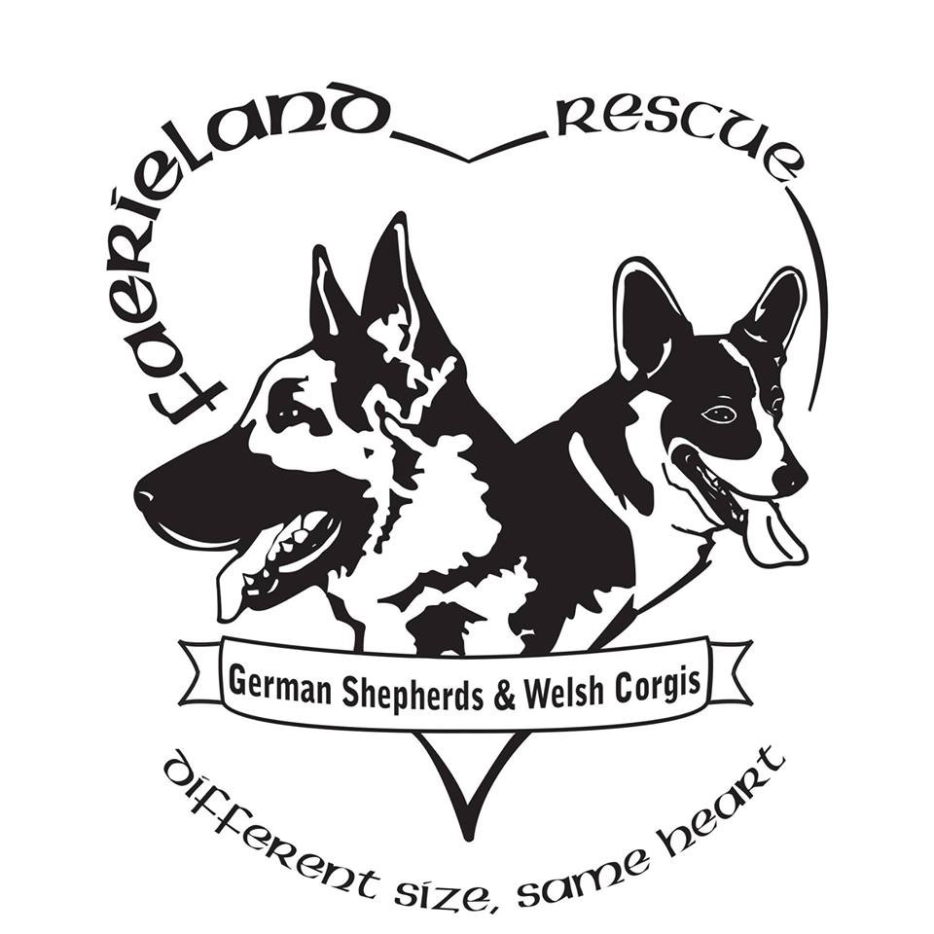 **Release of Dog Ownership**

Date: __________________

Name of Dog : ______________________________________________________ (include call name)

Breed: _____________________________________ Date of Birth: ______________________________

Color(s)/Markings of dog: __________________________ Scars / tattoos / injuries: __________________

Gender: Female/Male (circle one) Age: ______ Spayed/Neutered Yes / No Weight: ____________

Name of Veterinarian:___________________________________ Veterinarian Phone# ________________

Vet Hospital/Clinic: ______________________________________________________

City/Town: _________________________________ State: _____________Zip: _______________

Microchip**:** Yes/No: If Yes-provide Microchip # and brand ______________________________________ Medical Information: **(OWNER TO PROVIDE ALL MEDICAL RECORDS W/ DOG attach to the email.)

On heartworm preventative: Yes /No If yes, type/brand _______________________________________

Date of last heartworm pill______________ Date of last flea and tick pill and brand ______________

Date of last rabies vaccine: _____________________________Due next: ____________________________

Date of last DHPP: ______________________________Date of last Bordetella: _______________________

Type and brand(s) of dog food: __________________________________________

Amount/how often fed: __________________________________________________

Behavioral Issues: Yes /No

Include a bio on another page of your dog. Be sure to include the behavioral issues and all aspects of the dogs personality. We want to get to know your dog better and to do this we need to know why the dog is being surrendered

# RELEASE OF OWNERSHIP

I agree and understand that I am giving up all rights of possession and ownership of this dog. And that I will not be able to redeem said dog at any time, nor will I be allowed to know the dog's specific whereabouts. I agree and understand that said dog is now the “sole property” of FaerieLand Rescue. FaerieLand Rescue will not assume any financial obligations for monies spent on this dog prior to the surrender date.

I promise that the information that I am giving is accurate and that FaerieLand Rescue will not be held liable or chargeable for any false information or misrepresentations that I may have submitted on this form. I further agree and understand that FaerieLand Rescue will evaluate this dog to determine whether or not the dog being surrendered will be considered "adoptable." FaerieLand Rescue cannot guarantee placement.

I stipulate that the above information is true and correct to the best of my knowledge and I have divulged all pertinent information relating to this dog. I also stipulate that, to my knowledge, this dog has never bitten a human being or other animal. ___________

(initial here)

Please consider making a donation in regards to the surrender of this dog, which helps cover the cost of dog food and any vetting that will be upcoming. On the average it can cost us between $150.00 to $250.00 when we take in a new dog. We appreciate your donation and 100% goes to the dogs.

Please provide current vaccination records on your dog, including: Rabies, Heartworm test, DHPP, Bordatella & fecal test..

These are required. _________

Write a bio on the dog, describing the likes, dislikes, anything that will describe the personality of the dog. Attach another sheet if needed to provide as much information as possible. We want to get to know your dog so that we can rehome the dog in an appropriate home. (attach the bio the email)

This needs to be completed so the rescue can obtain any veterinary records

Veterinary Practice name

Veterinary address

Veterinary phone number

Veterinary email address

Dear Dr. _____________________:

I/We have transferred ownership of my/our Welsh Corgi/German Shepherd named __________ to FaerieLand Rescue. You are hereby authorized and directed to treat FaerieLand Rescue as the owner of this dog and to deliver to FaerieLand Rescue’s representative all medical records (including any X-ray films) of this dog. I/We would appreciate it if you would cooperate fully with FaerieLand Rescue and its representative regarding the medical history and treatment of this dog.

Thank you for your assistance.

"Giving veterinary care to your German Shepherd or Welsh Corgi will cost the rescue an average of

$250-$450. Would you like to donate to help cover the cost of care"? ____________________

This information is required to be completed in full

**Name of Previous Owner ______________________________________________________________**

**Signature of Previous owner: ________________________________________________________________**

**Previous Owners Address:______________________________________________________________ Phone:_____________________________________________________________**

**Date:________________________________________**